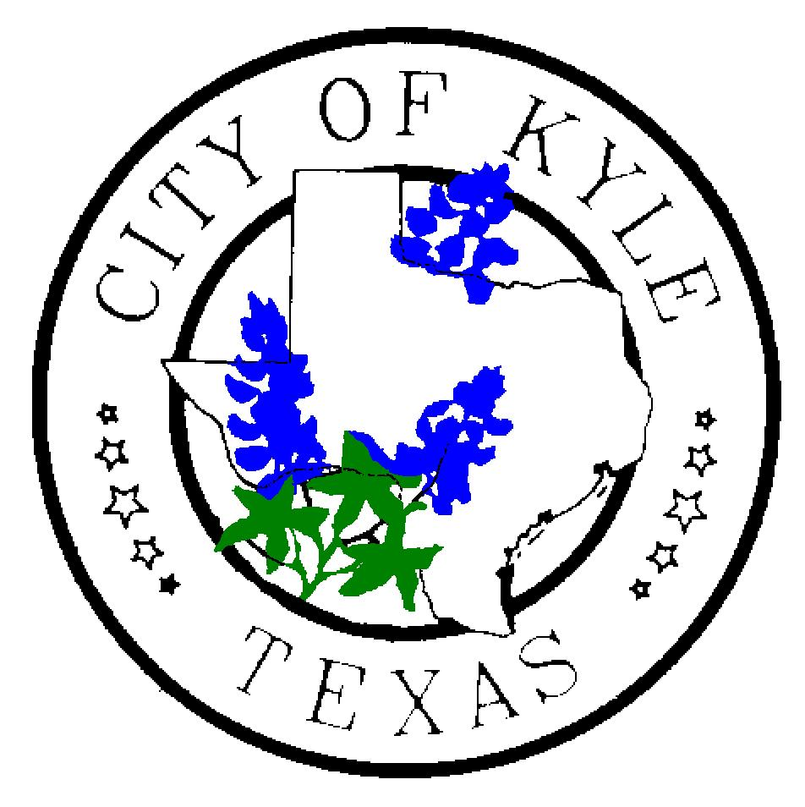

For Immediate Release For more information contact:
June 20, 2019 City of Kyle Kim Hilsenbeck, 512-757-4157

Kyle’s Economic Development Director is now a Master Practitioner

Kyle, TX – With its fast growth and evolving business landscape, as well as a diverse, educated and ample workforce, Kyle is a desirable location for large companies. Knowing how best to negotiate the kinds of development agreements that bring quality jobs is a skill, one that Economic Development Director Diana Torres possesses. Now following an intense, hands-on executive education course, she is also an Economic Development Master Practitioner through the Advanced Economic Development Leadership (AEDL) program.
Torres was among a select group of economic development professionals invited to attend the AEDL program. The two-week experiential course, developed by four partner universities — University of Alabama, Clemson University, Texas Christian University, and the University of Southern Mississippi — offered attendees the chance to explore topics that impact communities in their home state and across the country.
The advanced program faculty includes some of the nation’s best and brightest thinkers, strategists and implementers from site consultants to business leaders to nationally known subject experts and university professors. Topics tackled during the intense program were negotiation, communication, workforce/education, project management, community development, influencing change, international trade/foreign direct investment and other key subjects that impact quality job creation.
“The course took what I already knew and added more layers and complexity, helping me more completely recognize our city’s strengths and opportunities,” Torres said. “I learned that I had a lot of knowledge. But with the speed of growth and changing business climates, I am now better able to help Kyle reach its full potential.”
With an almost 20-year career, Torres is no stranger to what it takes to bring investment to a small city. Nearly 14 years ago, Torres came to work for Kyle and had to share a computer with two other staffers. She was here when the city installed its first stop light – that was in 2007.
Torres also helped the city navigate the challenges of growth and was at the helm for the city’s first “big” developments including Seton Hays Hospital (now Ascension Seton Hays), EVO, Kyle Marketplace, Kyle Crossing and Village at Kyle Retail Centers and ACC, among others. Her latest wins include Hays Logistics Center, Alsco, Majestic Kyle Business Park and ENF. Those developments will bring several hundred jobs to Kyle.
With her new diploma, Torres will continue her goals of bringing quality developments and good jobs to Kyle residents. She said the big difference is having an even stronger understanding of how economic development issues are interrelated and how she can be an even better advocate for convincing businesses to invest their dollars here in Kyle.
“That’s really what we’re asking of companies – to invest in us, to invest in Kyle,” Torres said. “The AEDL Program provided a strong framework for how negotiation can yield better results and understanding the connectedness of the various influences involved in economic development.”

###

