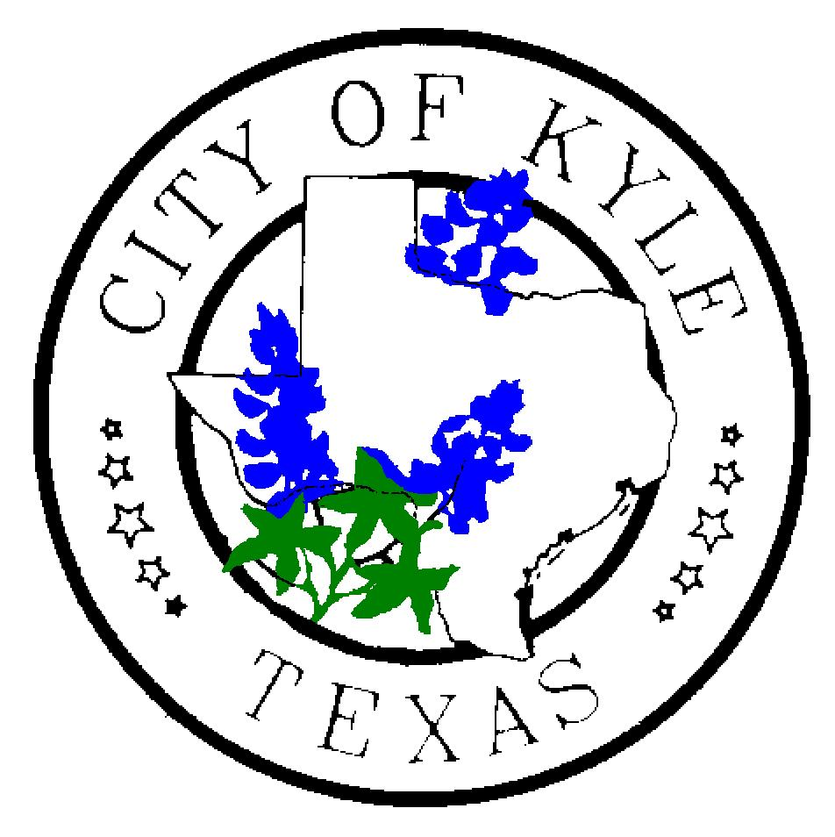

For Immediate Release For more information contact:
November 1, 2019 City of Kyle Kim Hilsenbeck, 512-757-4157

Kyle receives $1.8 M federal award for urgent road improvements
Kyle, TX – The City of Kyle is the recipient of a $1.8M award from the U.S. Department of Housing and Urban Development (HUD) to reconstruct a portion of Windy Hill Rd. at Richmond Branch. The city will contribute an additional $1.6M of its own funds toward the project.
The work will be performed between 500 ft. west of Cherrywood Dr. and 500 ft. east of Purple Martin Dr. These road and drainage improvements will facilitate travel between IH 35, FM 2001, and SH 21. This project will also improve travel for adjacent developments that are surrounded by low-water crossings with closure of Windy Hill at Richmond Branch.
Under the direction of the Texas General Land Office (GLO), the entity which will disperse the federal funds from HUD, Kyle will perform several improvements to Windy Hill including:
- Road widening
- Drainage improvements
- Adding turn lane capacity
- Installing safety lighting
- Enhancing pedestrian mobility
The city sought funding for this road work following two devasting floods in the Kyle area in 2015, along with numerous low water crossing closures during heavy rainfall.
Kyle Engineer Jo Ann Garcia said residents in neighboring areas of Windy Hill, including Meadows at Kyle, Amberwood and Indian Paintbrush, will be positively impacted by these improvements. She added that those living to the east of the city limits in Hays County will also be positively impacted.
Approximately 48 percent of residents residing in areas adjacent to the project area are low-to-moderate income, which allows the project to meet one of the provisions of this funding. The city was also able to show that the work is of a critical and urgent need, as many who reside in nearby developments are surrounded by low water crossings affecting their evacuation or travel out of the area during large rain events.
“When water on roadways closes or reroutes travelers, and when water rises to unsafe levels, that is a threat to public health, safety and welfare,” Garcia said. “This funding will allow us to make needed improvements to that stretch of road and ultimately improve the quality of life for many of our city’s residents and those who utilize our roadways in their daily travels.”
No displacement of homes or residents are anticipated with these improvements.

“Being the recipient of a federal award from HUD that will improve and enhance public safety is a real win for Kyle,” Mayor Travis Mitchell said. “By collaborating with entities such as HUD, our resources can be utilized in a more cost-effective manner.”

Written concerns, questions and complaints about the project can be submitted by mail or in person to Kyle City Hall, located at 100 W. Center Street, Kyle, Texas, 78640 (open Monday through Friday 8 a.m. to 5 p.m.), via email through the City of Kyle website, or by phone at 512-262-1010. For more information, please visit https://www.cityofkyle.com/finance/city-kyle-personnel-policy

Companies on the State of Texas Comptroller’s Office Centralized Master Bidders List were encouraged to review the requirements and submit bids that are responsive to the RFP. That RFP can be viewed here: https://www.cityofkyle.com/rfps
Garcia said she expects the reconstruction project timeline to last approximately two years, as the city will need to collaborate with other entities including Hays County. In addition, a large portion of the project is in the floodplain and the acquisition of adjacent properties will be necessary.
Updates on road construction are provided weekly on the city’s website and in its e-Newsletter (subscribe by emailing khilsenbeck@cityofkyle.com).

###

