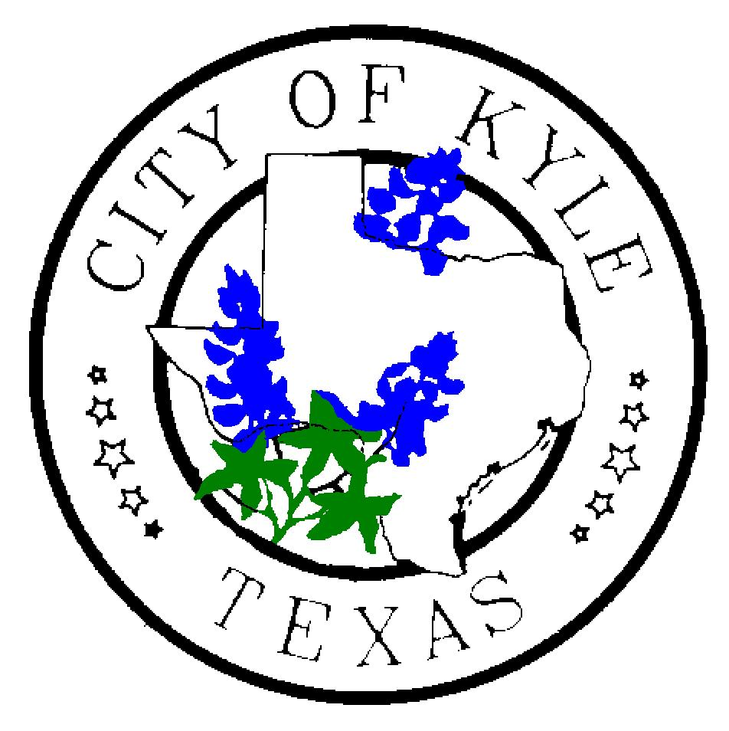

For Immediate Release For more information contact:
July 17, 2019 City of Kyle Kim Hilsenbeck, 512-757-4157

Kyle Pie in the Sky launches new festival additions this Labor Day weekend

Kyle, TX – With new festival components and even more fun planned, the annual Kyle Pie in the Sky Hot Air Balloon Festival will once again take flight this Labor Day weekend. This event, which began in 2017, attracts visitors from around the region and even out of state.
On Saturday and Sunday mornings, the balloons will launch simultaneously just after sunrise in what’s called a “mass ascension”. In the evenings, balloons will “glow” against the darkened sky while still tethered to the ground.*
The 2019 version of the event, held at Lake Kyle in Kyle, Texas, will feature added entertainment for the more than 22,000 attendees expected to attend this year’s high-flying festival.
“We wanted to offer even more fun to our guests,” Special Events Coordinator Sarah Watson said. “They will find some new festival experiences and we hope they will make a weekend of it.”
Among the new offerings, festival organizers added special kite shows featuring Austin End of the Line Kite Team. This four-man group performs musically choreographed kite shows around the country.
“We wanted to bring a fun new festival attraction to our patrons,” Watson said.
The team will perform 10 shows during Pie in the Sky over Friday and Saturday, including at night with kites that light up the sky. Kite performances, each about 10 minutes, take place as follows:
Friday
6:30 p.m., 7:30 p.m. and 9 p.m.
Saturday
8 a.m., 9 a.m. 11 a.m., 5:30 p.m., 6 p.m., 7 p.m. and 9 p.m.
Watson said End of the Line will also host kite-making workshops for kids on Saturday, Aug. 31 from
10 a.m.-noon and again from 5-8 p.m. Members of the team can be available for interviews.

Aside from balloon glows and kites, another way the festival will light up the night sky is with fireworks.
“We will do two fireworks shows during Pie in the Sky as an added attraction for our guests,” Watson said, “one on Friday night and one on Saturday.”
This year’s festival will feature about 25 hot balloons, including the returning “Center Stage” special shape balloon, a major attraction sponsored by Wells Fargo. Watson said three new special shaped balloons are also headed to Kyle: Spider Pig, High Jack and Ladybug.
She added that festival goers will also enjoy all the original event components.
“We will have pie eating contests by Broadway Bank, along with a pie baking contest and pie throwing,” she said. “Guests can continue to enjoy live music, great food, a children’s area and tethered balloon rides.”**
Guests will also find a variety of food and market vendors, a Pie Cafe and, on Saturday evening, a Pie Mall.
Watson invited anyone named Kyle (spelled that way) to once again participate in a ‘Gathering of the Kyles’ on Saturday morning — the intent is to build the foundation for a Guinness World Record for the most Kyles in one place. Past participants came from as far away as Massachusetts.
Information about Kyle Pie in the Sky Hot Air Balloon Festival is available on the website, http://www.pieinthesky.com/. From there, guests can use the Festival Guide to plan their Labor Day weekend in Kyle including purchasing tickets, getting directions and maps to parking lots, finding shuttle schedules and list of local hotels. Music line-ups will be announced throughout the summer and updated in the online guide.
No public parking will be available at Lake Kyle this year because of road construction. Watson said safety plans call for road closures and more shuttles to accommodate guests and help ease traffic when leaving the park.
Patrons should be aware that the festival takes a break on Saturday between noon and 5 p.m. During that time, visitors can enjoy a tour of the Historic Train Depot in downtown Kyle, play a round of disc golf or swim at the Kyle Pool. A variety of restaurants are also in the historic district and throughout Kyle.
A special media-only event takes place beginning at 6 a.m. Friday, Aug. 30. This is a great way to capture footage and photos, speak with pilots and even take a short hot air balloon ride (must RSVP).
###
* All balloon events are weather dependent.
**Tethered balloon rides are not included in festival ticket price; a portion of the fee will benefit the Kyle, Buda Kiwanis Club.

