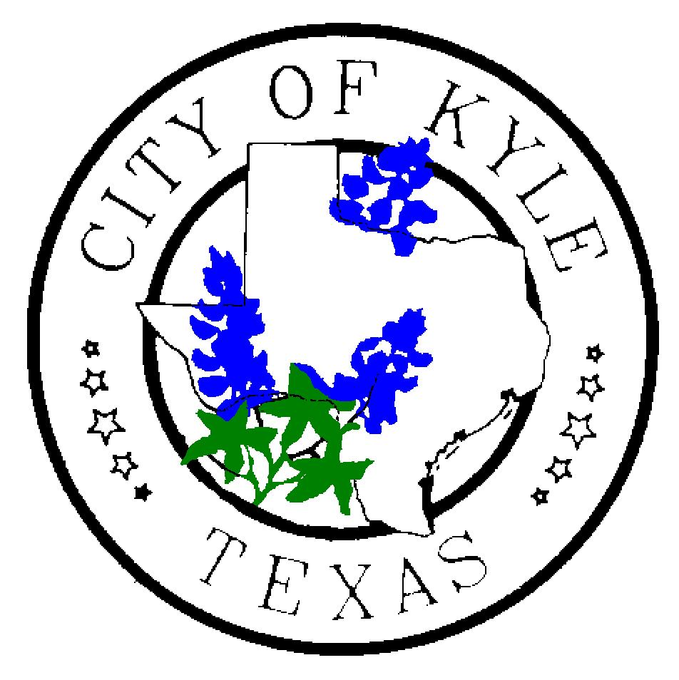

For Immediate Release For more information contact:
October 8, 2019 City of Kyle Briana Brecher, 512-268-3232

Kyle Police arrest four, including three juveniles, in car burglaries

Kyle, TX – Kyle Police arrested one adult and three juveniles in two cases of car burglaries that took place in the early morning hours of October 6 in the Meadows of Kyle neighborhood.
The 18-year-old is Anderson Ronayd Cortez of Austin. The three youths arrested along with Cortez are ages 16, 14 and 13. Two are Hispanic and two are African American.
All four were initially charged with two counts of Burglary of a Motor Vehicle and 1 count of Engaging in Organized Crime, which is a charge that is applied when three or more individuals are connected to the same crime.
Kyle Police Chief Jeff Barnett added that a spate of car burglaries and two vehicle thefts took place overnight Saturday on the following streets across several neighborhoods in Kyle: Purple Martin, Masonwood, Caraway, Brandi Circle, Hogan, Primrose, Cowboy Cove, Phillips, Dandelion and Fender.
Police were called to the scene by one of the victims who witnessed the young males rummaging through one of the vehicles.
Barnett anticipates that additional charges could be filed against the four males who were arrested as investigations are completed on other burglary cases.
The two vehicles that were burglarized by these four males were a 2003 Pontiac and a 2017 Chevy Malibu; one was unlocked according to the victim’s statement. The other victim said the burglars were able to get the spare key to her vehicle from her spouse’s car, which was parked next to it.
Kyle Police Chief Jeff Barnett said, “The items stolen from these two vehicles include sunglasses, phone chargers, knives, a cell phone, a wallet, gloves and an iPod.”
“We are actively looking for two stolen vehicles,” Barnett said. “One of them is a black 2003 Chevy Tahoe. It has a three-inch lift kit, chrome wheels, a temporary tag and a US Marine emblem on the back. The other vehicle is a 2010 maroon Ford Edge.”
If anyone has any information about the Tahoe and can provide information to police, please call the KPD non-emergency number, 512-268-3232.
Kyle Police Department reminds Kyle-ites to lock their vehicles at all times when not in use, and to remove valuables from vehicles when parking, even at home. They also discourage leaving spare keys to your residence and other vehicles in your vehicle.
###

