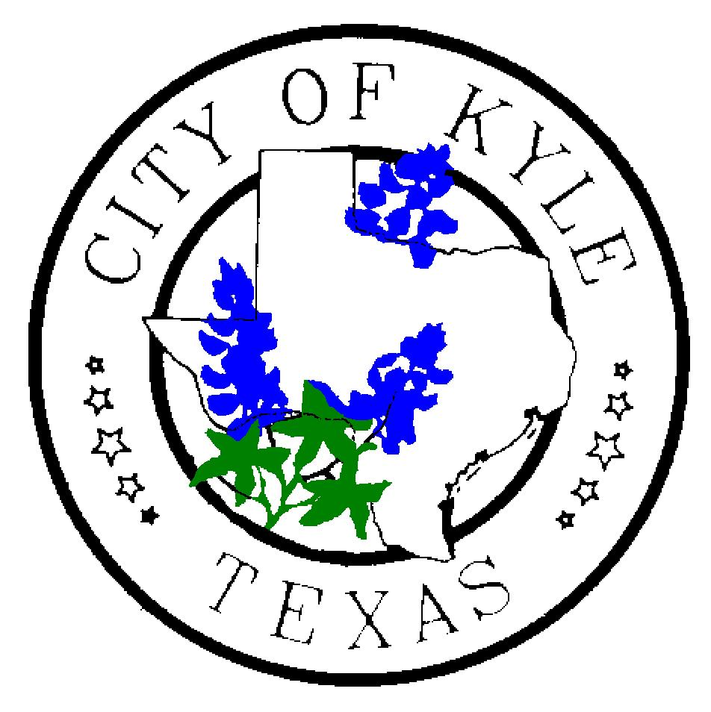

MEDIA REMINDER For more information contact:
September 29, 2019 City of Kyle Briana Brecher, 512-268-3232

Kyle police bringing neighbors together with National Night Out

Kyle Police are hosting a National Night Out (NNO) block party. We invite you to join us and/or to share this information with your respective audiences.
Event details:
- 6 p.m. to dark on Tuesday, Oct. 1, 2019, at City Square Park, located at 101 S. Burleson St.
- The Kyle Masons are offering sausage wraps and several local businesses will be on site.
- Kyle Area Youth Advisory Council will sell water and other drinks as part of its fundraising efforts.
For more information, visit our website: https://www.cityofkyle.com/police/national-night-out-2019

Thanks – we appreciate you!

ORIGINAL RELEASE BELOW:

Kyle, TX – With an emphasis on bringing neighbors together and developing relationships with the community, Kyle Police are once again hosting
Kyle Police Chief Jeff Barnett said it’s an opportunity for local residents to interact with law enforcement in a fun, relaxed setting.
“Each year, we encourage Kyle residents, particularly those in the downtown area, to come hang out with our officers and get to know each other,” he said. “National Night Out is also a great way to meet your neighbors and form relationships.”
Other NNO parties will also take place in neighborhoods across Kyle.
The goal of this 35-year old program is to promote involvement in crime prevention activities, police-community partnerships and neighborhood camaraderie.
KPD Animal Control Officer Briana Brecher, who has coordinated the police department’s NNO for several years, believes in the mission of event.
“Knowing your neighbors is a good way to help prevent crime and to become more vested in your community,” Brecher said.
When neighbors look out for each other, Barnett added, it is a deterrent to those seeking to commit crime. He said events like NNO and community watch programs can add value to any community.
“It sends a message to criminals letting them know neighborhoods are banding together and taking an active role in reducing crime,” Barnett said.
The KPD downtown block party takes place from 6 p.m. to dark on Tuesday, Oct. 1, 2019, at City Square Park, located at 101 S. Burleson St. The Kyle Masons are offering sausage wraps and several local businesses will be on site. Kyle Area Youth Advisory Council will sell water and other drinks as part of its fundraising efforts.
For more information, or if your neighborhood would like to host its own NNO event, visit our website: https://www.cityofkyle.com/police/national-night-out-2019
A full history of National Night Out can be found online at https://natw.org/.

###

